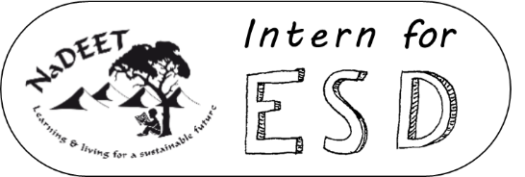

Intern for ESD – APPLICATION FORM 2022
Please complete this application form fully. Incomplete applications will not be considered.

- Personal information
First name(s) | Click or tap here to enter text. | Surname | Click or tap here to enter text.
Date of birth | Click or tap here to enter text. | Gender | Click or tap here to enter text.
Cellphone number | Click or tap here to enter text. | Email address | Click or tap here to enter text.
Postal address | Click or tap here to enter text. | Town | Click or tap here to enter text.

- Qualifications
Please note that you may not currently be studying or employed. You must have finished your studies no longer than three years ago.
What did you study?  (List all diplomas/degrees) | Click or tap here to enter text.
At what institution(s) did you study? | Click or tap here to enter text.
Year of completing your latest diploma /degree | ☐ 2021 ☐ 2020 ☐ 2019 ☐ <2018
Have you attended any EE/ESD training during your studies or in the last 3 years? | ☐ No  ☐ Yes, please specify where, when and duration:  Click or tap here to enter text.
Do you have a drivers license? | ☐Yes ☐ No

- Essay
Please motivate why you would like to become an environmental educator. (Max 200 words)
Click or tap here to enter text.
Word count: | Click or tap here to enter text.

- Supporting documents
Please indicate (☒)the supporting documents that you have attached below and submit them via email along with your application form to admin@nadeet.org:
☐ Curriculum vitae (CV)
☐ Certified copy of tertiary educational qualifications
☐ Certified copy of ID
☐ Certified copy of drivers (if applicable)
Optional: Personality Type (https://www.16personalities.com/free-personality-test) | Click or tap here to enter text.

